Step by Step Instructions for opening Project

1. Download the project. Optionally, It can be downloaded from GitHub link: <https://github.com/shubh2016shiv/CKD_prediction> as zip file as shown in snapshot below:

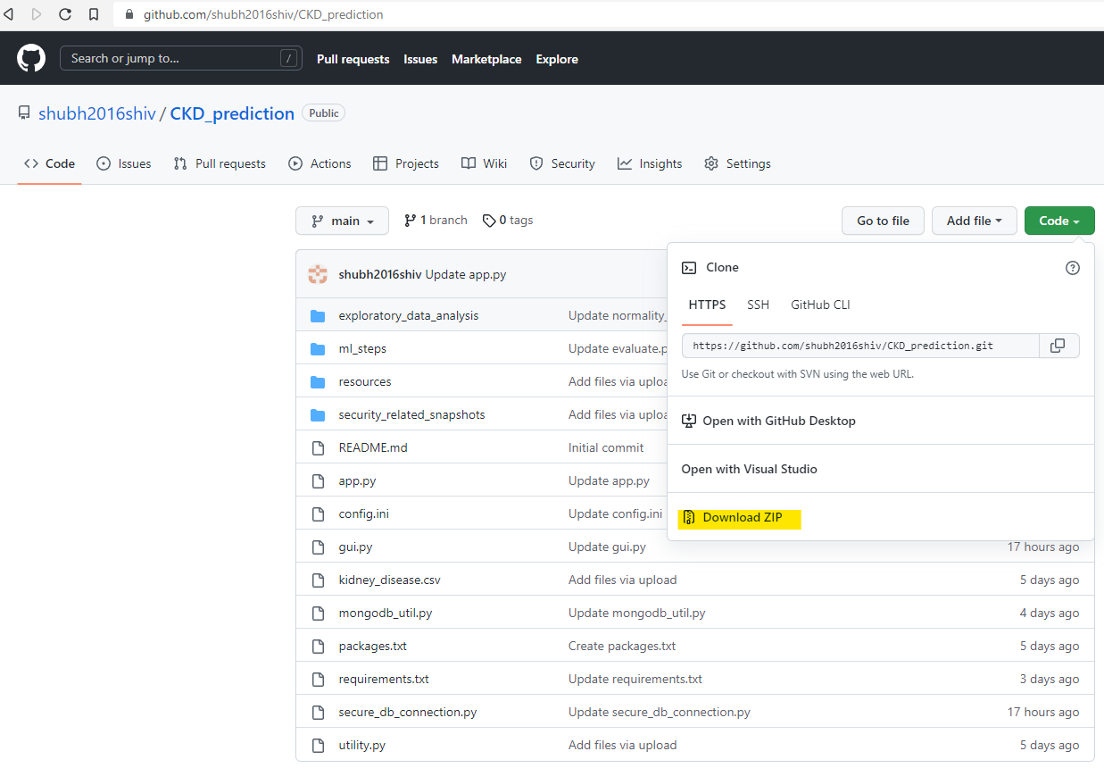

1. Keep the project in a folder on your computer and note down the path of the folder. For example: **C:\Users\Shubham Singh\OneDrive\Desktop\project\CKD_prediction-main**
2. Open ‘**Anaconda Prompt**’ application and navigate to same folder where project is there by using the command “**cd <project folder>**” (*replace the <project folder> with folder path where project is kept*) and run the python file ‘**gui.py**’ as shown in snapshot below.

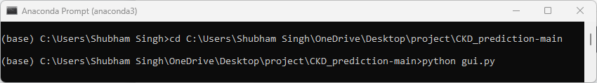

1. Below GUI program will show up. Use the credential given below for read-only authentication of accessing MongoDB and click on ‘Open Application’ button

*Username* : assessment_user

*Password* : Wel3g23U1Zxmf7dI

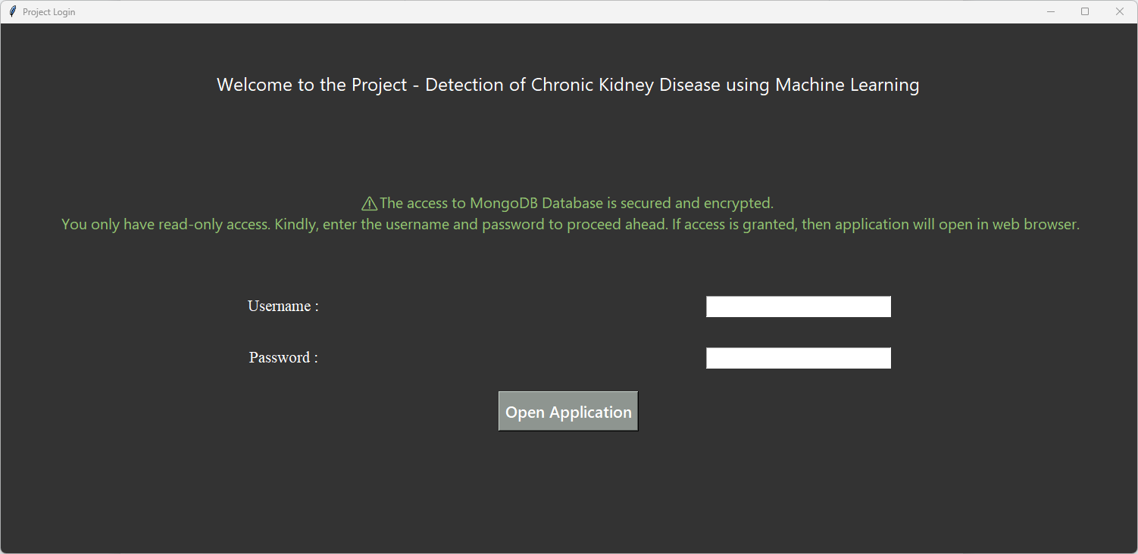

1. A website will open up on browser. Here, authenticate your access to this application using below credentials and click ‘Login’:

*Username : admin*

*Password : abc123*

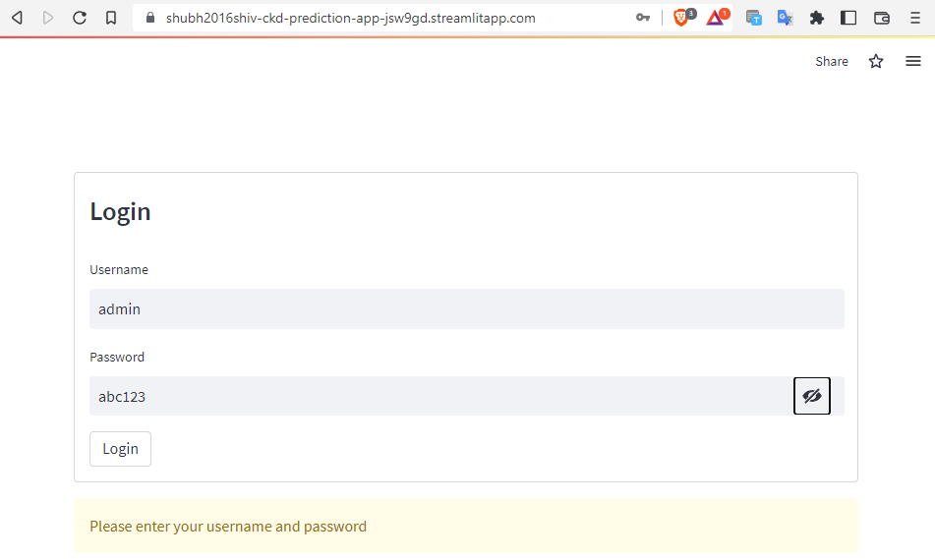

1. Finally Machine Learning application will open as shown below:

